Chapter 18, Solution 35.

- x(t) = f[3(t-1/3)]. Using the scaling and time shifting properties,

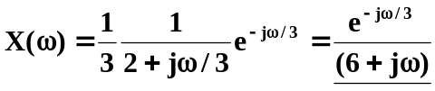

- Using the modulation property,

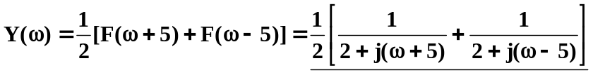

(c ) 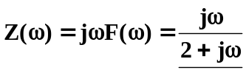

(d) 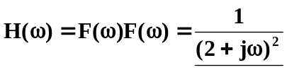

(e) 